# Testing:

### User Story: Student Upload Form

|  |  |  |  |  |  |
| --- | --- | --- | --- | --- | --- |
| **Test Case Type** | **Description** | **Test Steps** | **Expected Result** | **Actual Result** | **Status** |
| Usability | Loading up the webpage. | Access the serverurl:port/ newStudentUpload | Page loads that prompts user to upload/download the form document or use the online form. | Page loads that prompts user to upload/download the form document or use the online form. | PASS |
| Functionality | Accessing the web form from the upload file section. | Access the student upload page, click on button “Student form” | Redirects to student form website. | Redirects to student form website. | PASS |
| Functionality | Browse file button needs to allow the user to select a file. | Visit the student upload page, click on “browse”. | “Upload file” application pops up. | “Upload file” application pops up. | PASS |
| Functionality | Submit button needs to send the file to the backend so that the reading process can be done. | Visit student upload page, click on “submit” | Upon clicking the submit button, the file is sent to the server to be processed. | Upon clicking the submit button, the file is sent to the server to be processed. | PASS |
| Functionality | Information that is read from the file should be inserted into the database/ | Open up the webpage, submit a file. | Everything should be converted to the correct data type and put in the database. | Correct data type in the database and everything is stored appropriately. | PA |

### User Story: Placement Provider Upload Form – Completed by @aamd1 Abdulqader

|  |  |  |  |  |  |
| --- | --- | --- | --- | --- | --- |
| **Test Case Type** | **Description** | **Test Steps** | **Expected Result** | **Result** | **Status** |
| Usability | Checking that the form is accessible | Accessing domain/newCompanyUpload | The form is loaded with all features. | The form is loaded in the browser. | PASSED |
| Functionality | Checking the application can be run | Running the application | Application running | The application crashed due to dead code that was used for testing. | FAILED. The dead code was deleted to allow for other tests. |
| Functionality | Browsing and Uploading | Click on “Browse files” and select a file to be uploaded then press upload. | System Files can be browsed, and a file is chosen then uploaded successfully, | Files can be browsed and selected but when trying to upload the file cannot be uploaded. | FAILED |
| Functionality | Downloading an empty placement form | Click on “Download The Form”. | The from starts downloading. | Clicking on “Download The Form” the page shows a Whitelabel error. | FAILED |
| Functionality | Being able to fill the online form instead | Click “Placement Provider Form” | After clicking the link the form should show the online form. | The online form was shown. | PASSED |
| THE TESTING PROCESS WAS PAUSED AS THE REST OF THE TESTING REQUIRES THE PREVIOUS TESTS TO PASS SUCH AS CHECKING THE DATABASE CAN ONLY BE DONE WHEN A FILE CAN BE UPLOADED. | | | | | |
| The errors were fixed | | | | | |
| Functionality | Information stored in the database | Upload a form and check the database. | Values in the database. | Values were found in the database. | PASSED |

### User Story: Contact (Email)

|  |  |  |  |  |  |
| --- | --- | --- | --- | --- | --- |
| **Test Case Type** | **Description** | **Test Steps** | **Expected Result** | **Result** | **Status** |
| Usability | Launching the contact Company page | Requesting the mapping on the local host | Taken to the contact company page | Taken to the contact company page | Passed |
| Usability | Launching the contact student page | Requesting the mapping on the local host | Taken to the contact student page | Taken to the contact student page | Passed |
| Functionality | Inputting information into provided fields | Entering sample information into provided fields | Sample information will be accepted and submitted | Sample information was accepted and submitted | Passed |
| Functionality | Opening default email client to contact student/ company | Submitting sample information | Default email client pop up with sample data entered automatically | Default email client popped up with sample data entered automatically | Passed |
| Functionality | Link to Assessment Form | Click “Go to” link | Redirect to an assessment form | Redirected to assessment form | Passed |

User Story: Tracking :

As a Placement Team (Member)

I want to be able to keep track of all students that are on a placement

So that I can contact them and monitor their progress.

|  |  |  |  |  |  |
| --- | --- | --- | --- | --- | --- |
| **Test Case Type** | **Description** | **Test Steps** | **Expected Result** | **Actual Result** | **Status** |
| Usability | Checking the application can be run | Pressing the start button | I expected it to run successfully | Says there was no PlacementRepository, but this was due to not adding .java to file name, also had to add an import and one of the imports were incorrect, causing another non run. | It runs now after I added fixes |
| Usability | Checking /Placementstudents opens successfully  **Unsure about the naming convention for this** | Requesting the mapping on the local host | Successfully opens | Successfully opened | Passed |
| Visibility | Expect the layout to be presentable and readable | Checks whether it is easy to understand the content of the page and if there are elements present where they are not supposed to be | Complete css, easy to read column headers, no extra elements on the page | Seems to include stray comments in the code, column headers are hard to read  **See below image** | Failed |
| Functionality | Be able to view the instances of students and their details | Run with mock data in the SpringBootApplication class | To show students details on the web page | Successfully showed an instance of data | Passed |

**I have fixed all errors to GitLab except the css visual problem shown below**

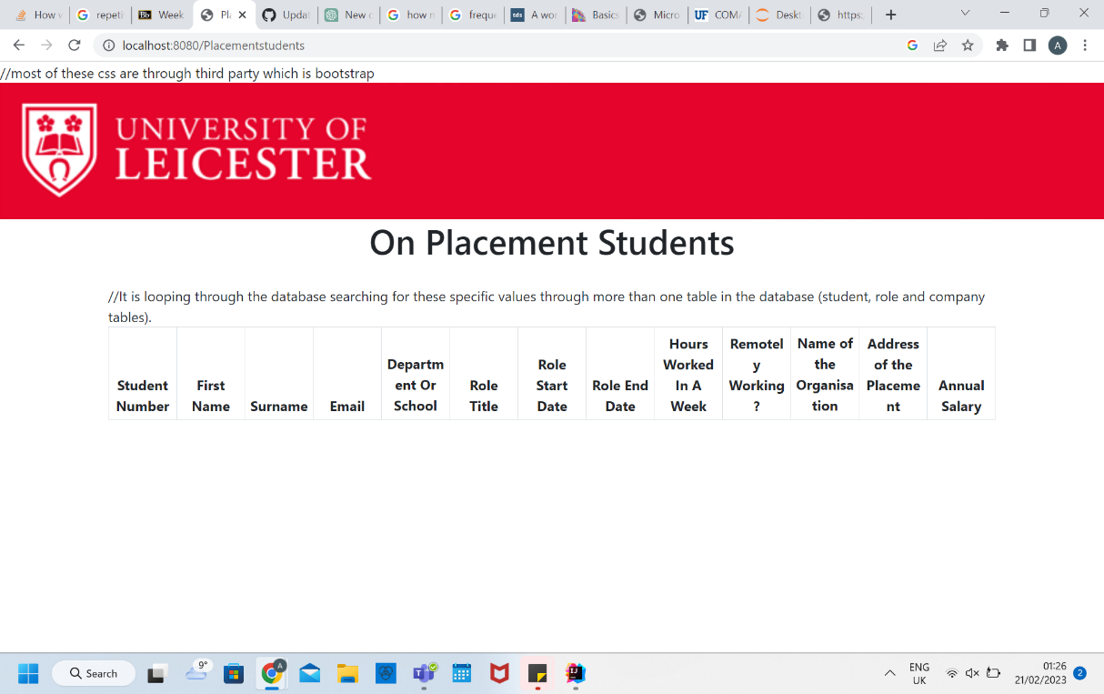

# Reviewing:

### User Story: Student Upload Form

* This code in the StudentUploadController java class is a bit dangerous. I uploaded an empty student form from my downloads, and it tried to delete this. I’m not exactly sure if this was intentional but this looks like it could cause permanent damage to someone’s files without their permission: C:\Users\mgadi\AppData\Local\Temp\tomcat.8080.7118185788097652543\work\Tomcat\localhost\ROOT\upload_8807b17a_25a4_43cd_be25_76fe4d12f49a_00000001.tmp

// Delete the temporary file  
storedFile.delete();

* When uploading a file, there should be some sort of indicator to show a file has actually been selected so they can click submit. A way to do this is by having the file name appearing under the browse files button.
* Also when pressing submit, a good idea would be to have a green check mark next to it to show it was successful, rather than in the box on the bottom right, as it is harder to notice, and not common practice
* Add an introduction comment section please to your StudentUploadController and UploadHelperMethods with your author name, so if in future there are any problems with the file, people can ask you
* Naming in UploadHelperMethods: There is a variable of type SimpleDateFormat used twice called “dateFromat”. Should be “dateFormat”. Please fix spelling mistake
* Looks like good amount of comments

### User Story: Tracking:

* Placement.java inside the model directory has a “getId()” method but the id is auto generated, it must be deleted.
* By convention the attributes must be BEFORE the methods. The order must be changed.
* CSS is in the JSP file, by convention should be moved in a separate file.

### User Story: Company upload:

* The jsp file has a commented link that should be removed if it’s not used, same for the helper.js file.
* There is a wrong like to a “Downloadable” directory that doesn't exist.
* The html tag at the bottom of the page is commented out, and it shouldn’t be.
* UploadHelperMethods.java has repetitive comments.

User Story: Contact

* There is text in the email and the subject which should be removed

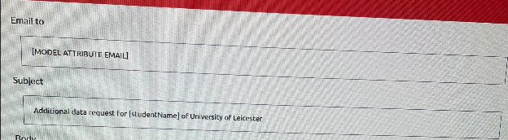

* Comments are clear and well understood
* CSS looked good